

**SUBMITTED BY:**

**OLUGBADE EMMANUEL DUNMININU**

**AT:**

**CIRVEE TECH INSTITUTE**

**SUPERVISOR: EMERUWA GRACE**

**OCOTOBER 2024**

**DATA ANALYSIS:**

**SUSTAINABLE JOBS AND SKILLS AGAINST INFLATION IN NIGERIA (2024)**

**SUMMARY**

**Brief Overview Of The Project:**

The data analysis focuses on identifying and analyzing sustainable jobs and skills with high-growth, high-paying careers and top rated job that can resist inflation in Nigeria.

**Key Findings And Recommendation:**

**Key Findings:**

1. **Inflation-Resistant Jobs:**

Cyber Security Specialist, Data Scientist, Medical Specialist, Software Developer has high inflation resistance than other sustainable jobs.

1. **High-Growth Jobs:**

Renewable Energy Engineer, Cyber Security Specialist and Data Scientist has high growth rate of 20%, 18%, 18% respectively. This means they are in high demand although among the three, Renewable Energy Engineer has low inflation resistance with a better average salary than Cyber Security Specialist.

1. **High-Paying Jobs:**

Software Developer, Medical Specialist and Data Scientist (In order of pay) among top 10 are highly paid. Although all these top three has high resistance to inflation but Data Scientist has higher growth rate than the other two.

1. **Top-Rated Jobs:**

Medical Specialist has the highest rating of 5/5 than others.

**Recommendations:**

Based on the key findings, the following recommendations are proposed to leverage Nigeria's inflation-resistant, high-growth and high-paying job opportunities:

1. People should consider high resistance sustainable jobs and skills for a good standard of living
2. Awareness programs on skills and job with high resistance to inflation especially the ones in high demand should be organize.
3. Implementing skills development programs for jobs.
4. Enhancing monetary policy for skill acquisition for jobs.

**INTRODUCTION**

**1.0 INTRODUCTION**

Nigeria's economy is moving to 29.90% inflation in January 2024, up from 28.92% the previous month as brought alarm and trend underscores to identify resilient jobs and skills capable of withstanding economic inflation.In this context, understanding the intersection of sustainable jobs with growth prospects and resistant to inflation and remuneration is vital. This report presents key findings on Nigeria's most inflation-resistant, high-growth and high-paying jobs, alongside recommendations for a good standard of living.

**1.1 AIM**

To analyze and report on the sustainable jobs and skills with high resistant to inflation in Nigeria.

**1.2 TOOLS USED**

1. Excel

2. SQL

3. PowerBI

**LITERATURE REVIEW**

**2.1 OVERVIEW**

Research indicates that inflation the persistence increase in the price of goods and services is a negative impacts to job and employment (Ajayi & Ojo, 2020; Oyinlola, 2019). Nigeria's inflation rate fluctuated between 11% and 18% from 2018 to 2022 (Nigerian Bureau of Statistics, 2022). However there are sustainable jobs and skills that make person live above the inflation.

## 2.2 Sustainable Jobs and Skills

**1. Agriculture**:

This employs 30% of Nigeria's workforce (Food and Agriculture Organization, 2020

1. **Renewable Energy**:

This offers job opportunities in solar, wind and hydroelectric power (International Renewable Energy Agency, 2020).

1. **Technology**:

This drives innovation and entrepreneurship (National Information Technology Development Agency, 2020).

1. **Healthcare**:

This experiences growth due to increased demand (World Health Organization, 2020).

**Essential skills include:**

Digital literacy,

Critical thinking,

Communication,

Data analysis,

Computer Knowledge e.t.c

**METHODOLOGY**

**3.1 DATA COLLECTION**

Based on the high interest of the analysis uncleaned data was collected from various sources online and saved to an excel worksheet having three sheets.

**Sheet 1:** Nigeria Sustainable jobs (6 Columns and 10 Rows)

Header Includes: S/N, Job Title, Average Salary (NGN), Growth Rate (%) Inflation Resistance , Skill Requirements.

**Sheet 2:** Job and skills requirement (4 Columns and 10 Rows)

Header Include: S/N, Skill, Job Title, Importance (1-5)

**Sheet 3:**  Inflation resistance data (2 Columns and 10 Rows)

Header Include: Job Title, Inflation Resistance (High/Medium/Low)

**Sources:**

1. National Bureau of Statistics (NBS) - Nigeria

2. Nigerian Labour Market Report 2022

3. Jobber man Nigeria Salary Report 2022

4. PWC Nigeria's 2024 Economic Outlook

5. World Bank's 2024 Nigeria Economic Update

**Data set now on Kaggle:** dunmininuolugbade/sustainable-jobs-and-skills-resistant-to-inflation

**3.2 DATA CLEANING**

**Data Cleaning Steps :**

Tool Used: Excel

Excel was used to carry out the following steps:

1. Duplicates , missing values, and blanks are checked and necessary corrections were made in the three sheets.
2. Data types for each column was checked and fixed to the correct format
3. “S/N” column was dropped
4. Header Name “Importance (1-5)” was renamed to “Ratings”
5. Job Title and Job resistance rate where place properly into individual column.

Other necessary cleaning process was done and the tables were saved into three different tables before joining them in SQL.

**3.3 Table Joining:**

Tool Used: SQL

SQL was used to join the three tables together using queries before importing the table as one for further manipulation in Power Bi.

**3.4 Other Measures and manipulations:**

Tool Used: Power BI

1. The mean from the “rating” column that involve the same job but different skills was used for average rating.
2. “Skills” column was dropped for further analysis
3. “Job title” was rename to “Job”
4. All data type was checked for appropriate report

Other measures was done for proper visuals on the report.

**RESULTS AND DISCUSSIONS**

**4.1 DATA VISUALIZATION**

**Dashboard:**

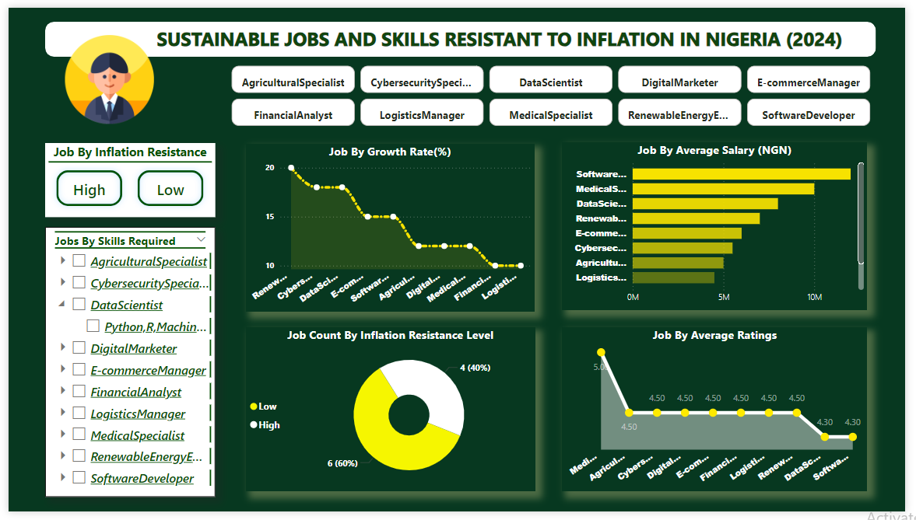

**Note:**

1. Each Job can be clicked on to get specific insight on each job across the report
2. Comparison among Jobs can be done at the left side of dashboard across the report.

**4.2 DISCUSSION**

**Key Findings:**

1. **Job by inflation Resistance Level:**

Cyber-Security Specialist, Data Scientist, Medical Specialist, Software Developer has high inflation resistance than other sustainable jobs.

1. **Job by Growth Rate:**

Renewable Energy Engineer, Cyber-Security Specialist and Data Scientist has high growth rate of 20%, 18%, 18% respectively. This means they are in high demand although among these three Renewable Energy Engineer is has low inflation resistance with a better average salary than Cyber-Security Specialist.

1. **Job by Average Salary:**

Software Developer, Medical Specialist and Data Scientist (In order of pay) among top 10 are highly paid. Although all these top three has high resistance to inflation but Data Scientist has higher growth rate than the other two.

1. **Job by Rating:**

Medical Specialist has the highest rating of 5/5 than others.

**CONCLUSION AND RECOMMENDATION**

**5.1 CONCLUSION**

Inflation significantly impacts job sustainability in Nigeria, particularly to live above inflation there are required job with specialized skills needed to have a good standard of living. Knowing the jobs and having the skills brings about adequate income to live above inflation. With this research people will focus on skills that brings about high resistance job against inflation most especially skills with high growth rate and high resistance to inflation over a long period of time so as to live above inflation in Nigeria.

**5.2 RECOMMENDATIONS**

Based on the key findings, the following recommendations are proposed to leverage Nigeria's inflation-resistant, high-growth and high-paying job opportunities:

1. People should consider high resistance sustainable jobs and skills for a good standard of living
2. Awareness programs on skills and job with high resistance to inflation especially the ones in high demand should be organize.
3. Implementing skills development programs for jobs.
4. Enhancing monetary policy for skill acquisition for jobs.

**5.3 LIMITATIONS**

Data sourcing limitation

**5.4 FUTURE RESEARCH DIRECTIONS**

1. Analysis on each skills in various job sectors should be carried out so as to know the best rated skill for effectiveness in each job sectors along side with each skill ratings and job growth.

2. Analysis on cost requirement for acquiring skills for various job.

**REFERENCES**

Ajayi, M. A., & Ojo, O. (2020). Inflation and Unemployment in Nigeria. Journal of Economic and Financial Studies, 8(2), 1-12.

Food and Agriculture Organization. (2020). The State of Food Security and Nutrition in the World.

International Renewable Energy Agency. (2020). Renewable Energy Market Analysis.

National Information Technology Development Agency. (2020). National IT Policy.

Oyinlola, M. A. (2019). Sustainable Development and Inflation in Nigeria. Journal of Sustainable Development, 12(3), 1-15.

Nigerian Labour Market Report 2022

National Bureau of Statistics (NBS) - Nigeria (2022)

World Health Organization. (2020).

Global Health Workforce Network.

World Bank's 2024 Nigeria Economic Update